May 11, 2021

Dear Middle and High School Students & Parent(s) of RSU 23,

In partnership with Southern Maine Health Care, we are pleased to offer on-site vaccine clinics at Old Orchard Beach High School for all RSU 23 students ages 12 and older with signed consent forms on Monday May 17th in the afternoon from 1:00 pm to 5:00 pm. Please note, the second doses will be scheduled for Monday June 7th during the same time slot.

The COVID-19 vaccine is provided at no cost. A fee for administration of the vaccine will be billed to your insurance carrier with no out-of-pocket cost to you. Please bring your insurance information to your appointment. You will not be denied the vaccine if you do not have insurance.

Attached for your convenience are the consent form, the registration form, the Pfizer information sheet, a pre-vaccine checklist and a post vaccine care sheet. Please complete the online registration form by Friday, May 14th by 12:00pm that is linked here - Student Vaccination Registration Form (http://bit.ly/RSU23StudentVaccineForm). If you are unable to access the online form for any reason, please use the form attached below and return it to the Old Orchard Beach High School Main Office. Please be sure to bring the signed consent form to the appointment. We will be scheduling the appointments in 15-minute time slots and you will receive notification of your students’ appointment. If you would like to accompany your child for their vaccination you may.

You can also visit our website www.vaccine.mainehealth.org for more vaccine information and FAQs (also available in 10 additional languages).

If you have any questions, please contact Susan Keiler at skeiler@smhc.org or at 207-283-7238.

Thank you for doing your part to bring an end to this pandemic.
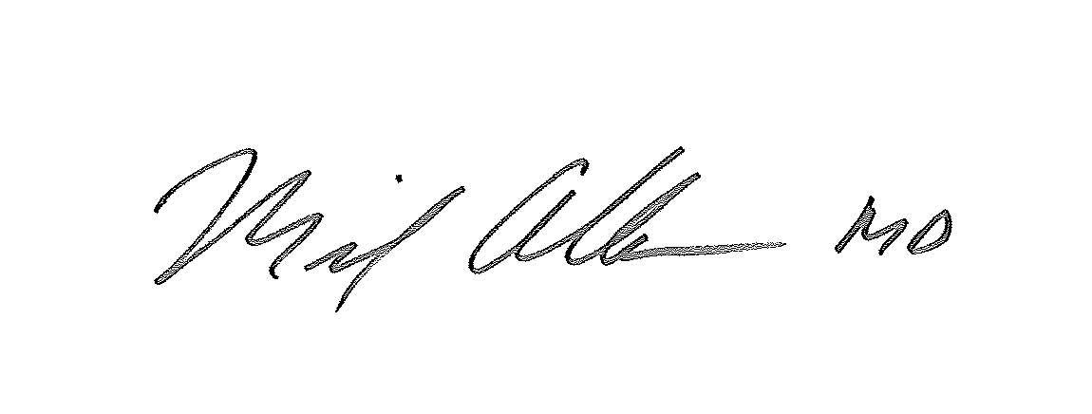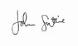

Michael Albaum, MD John Suttie
Chief Medical Officer Superintendent of Schools
Southern Maine Health Care RSU 23 School District

